Logarithms  Quiz-Answer | Name:  Date:

- Write the exponential equation in logarithmic form.
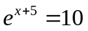 Answer: 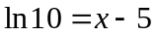

- Write the logarithmic equation in exponential form.

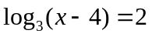 Answer: 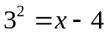

- Graph the function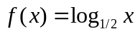. Specify its domain, range, and asymptote.

- Write as a single logarithm.
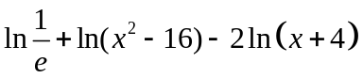 Answer: 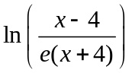

- Write as a sum and/or difference of logarithms.
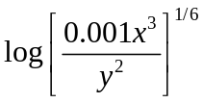 Answer: 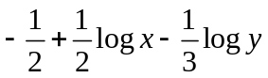

SELF-REFLECTION:

Which segment of the logarithms was most challenging for you?

What steps are you going to take to learn this subject?

